Data Mining Report

Diabetic Patient Readmission

**Under the Guidance of: Dr. Yinfei Kong**

**Table of Contents**

Introduction 2  
Data pre-processing and exploration. 4 Dimension reduction/aggregation 8 Data Mining Algorithms 10  
Model Interpretation 22  
Conclusion 25

**Executive Summary**

The dataset is about readmission of diabetic patients into hospitals. The data is collected from 130 hospitals over a span of 10 years (1999-2008). It has a total of 100K records and 50 variables among which 30 are categorical and 11 continuous. After data preprocessing and data cleaning, we have 49734 records over 30 different predictors to classify the readmission of a diabetic patient.

The extensive Data preprocessing steps include omission of variables and records containing a large number of missing values. Data preprocessing also includes categorical reduction, outlier smoothing etc. The dataset includes 3 categorical variables that have 848 distinct values, which have been reduced to 18 different ICDS codes and then these variables have further been reduced to 8 distinct values to simplify the model. The output variable, “readmitted” has 3 categories that has been reduced to 2. The categorical reduction has been performed on the basis of the frequency of the values in the dataset. If the frequency of the value is low, then they have been reduced to further fewer categories. The dataset has been partitioned to build and validate the model accurately. 60% of the dataset, called training dataset, has been used to build the model and rest 40%, called validation dataset, has been used to validate the model.

Out of the various classification algorithms, we have implemented CART and Logistic Regression on the dataset. We have performed 2 class classification where these two algorithm are implemented over the full dataset as well as the reduced dataset. In logistic regression, we have implemented the forward variable selection method to perform variable reduction, which will avoid model overfitting. We have drawn lift curve, confusion matrix, and AUC to determine the accuracy of the model. Another Algorithm is CART, which uses the full dataset to build the model. The CART algorithm is extremely simple and contains just one variable to classify the readmission of a patient. In real life, it is impossible to classify the readmission by considering just one predictor. We have implemented the Full tree and the Best-Prune tree, both of which have given similar results.

Accuracy was used as a constant metric to evaluate our model. The Forward selection method for Logistic Regression gave us a better accuracy i.e. about 65%, whereas the trees formulated in CART is simple and show only one variable to classify the upcoming data as readmission or not, which is ideally not possible. Hence, it is discarded. The Logistic Regression model gave us the best results. Also, we discovered that the duration of being admitted and medication administered are the two variables that play an important role for a person likely to be readmitted to the hospital, including the race and age variables.

**Introduction**

Due to the regulatory requirements, healthcare has always been a data intensive industry and according to a report in 2012, the total data collected reached 500 petabytes. In order to improve the efficiency of these industries, they have come up with the idea of employing data analysts who deal with this huge volume of structured and unstructured data and transform them into useful insights. Since the healthcare data has become such a big deal, we thought of employing several data mining techniques on one such healthcare dataset - Clinical Care Diabetes dataset

**Background**

We have pulled our dataset from the dataset aggregator Kaggle.com. The original dataset was submitted by the Centre for Clinical and Translational Research, Virginia Commonwealth University. The dataset represents 10 years spanning from 1999-2008 of health care data at 130 different US hospitals. It has over 45 features representing patient and hospital outcomes.

The data was extracted from a database for encounters that satisfied the following conditions:

1. It is a hospital admission.
2. It is a diabetic encounter, that is, one during which any kind of diabetes was entered to

the system as a diagnosis.

1. The length of stay was between 1 day and 14 days.
2. Laboratory tests were performed during the encounter.
3. Medications were administered when admitted.

**Characteristics of the Dataset**

*Figure 1: Dataset characteristics*

Among the 50 variables, Categorical variables are 39 and the rest 11 are Continuous variables.

**Problem Description**

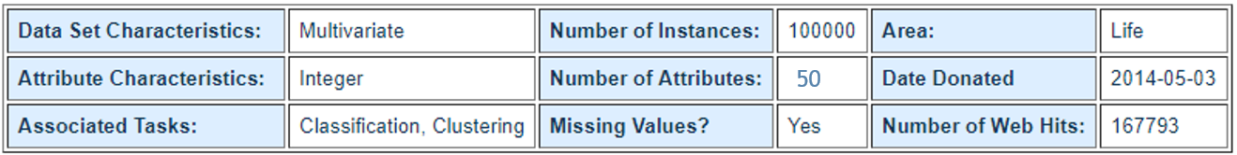

The main question of interest is:

**To know if a patient will be readmitted into a hospital?**

It is important to know if a patient will be readmitted in some hospital, reason being we can change the treatment, in order to avoid a readmission or work on the factors that influences the readmission.

In our dataset, we have 3 different outputs:

1. No readmission
2. A readmission in less than 30 days
3. A readmission in more than 30 days

**Description of Variables**

Here we can see different objective functions for the problem. We can analyze and figure out situations where the patient will not be readmitted, or if they are going to be readmitted in less than or more than 30 days.

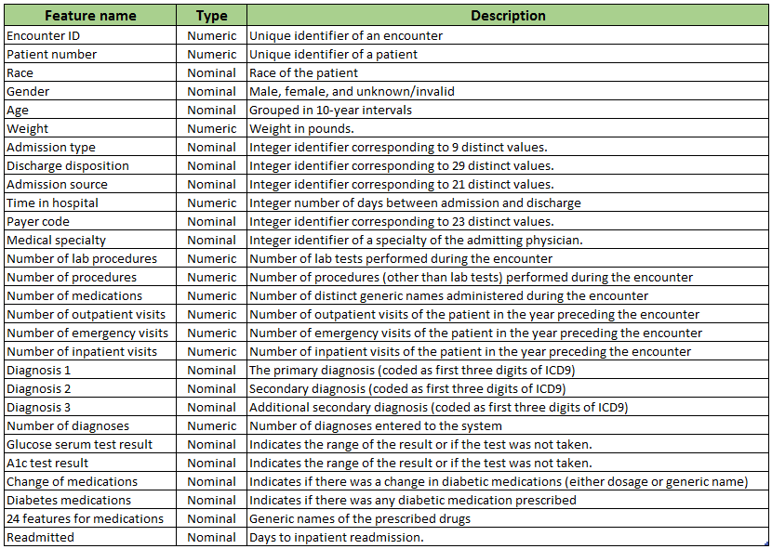

**Data pre-processing and exploration Detecting missing values**

The medical dataset consists of real world encounters of diabetes patients, hence to protect the privacy of the patients, the dataset is deidentified. Therefore, the dataset had a few missing values. Figure 2 is the heat map of the missing values in the dataset which shows that the variables weight, payer_code and medical specialty have maximum number of missing values. The missing values are depicted with yellow color in Figure 2 and the above mentioned three variables have most of the yellow color. Similarly, the variables diag_1, diag_2, diag_3 and race had a few missing values. To be precise, the weight variable had 96.8%, payer_code had 39.5 %, medical specialty had 50 %, race had 2.23 %, diag_3 had 1.39 %, diag_2 had 0.35 % and diag_1 had 0.02% of missing values.

Data Mining Report on Diabetic Patient Readmission

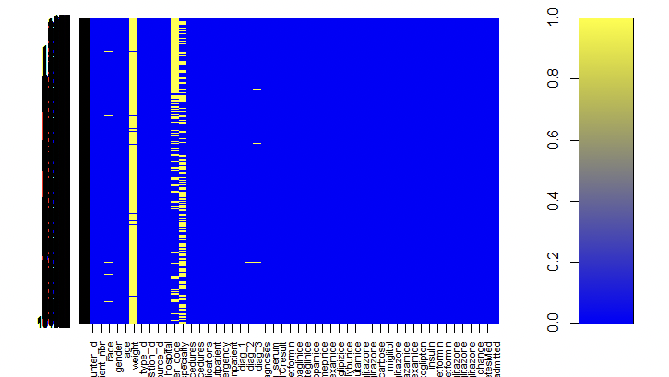

*Figure 2: Heat map of missing values*

**Reducing columns**

The first step implemented to handle the missing value was to remove the columns having major missing value. Therefore, the weight variable was removed as it had almost the entire column filled with null values. After analyzing the dataset for reducing columns, it was observed that the 24 medication variables could be reduced to fewer variables. The medication variable has 4 categories as shown in Figure 3. If the medication had No category in majority and the steady category had observations less than 2 % of total observations, then getting rid of that medication was a better choice as that medication was not prescribed to the majority of the diabetes patients. Hence, it would be safe to conclude that the medication is not generally prescribed to diabetes patients and it would be of no use in the making of the model. By the end of this process, 50 variables were reduced to 30.

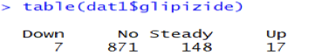

*Figure 3: Frequency of categories of Glipizide medication variable*

**Reducing rows**

After the column reduction, the row reduction process was performed on the remaining dataset. As the variables payer_code and medical specialty had almost 50% of their values missing, upon removal of these missing values the dataset was left with around 60k observations. This process was further performed on the variables race, diag_1, diag_2 and diag_3 and the dataset had 49734 observations by the end of this process. Therefore, after reducing columns and rows, the dataset had 30 variables and 49734 observations.

**Detecting Outliers**

Outlier detection is a very important step in the data preprocessing process as they are responsible for data skewness. And data skewness leads to incorrect model results, hence detecting and removing outliers is very crucial. The outlier detection was 8 continuous variables in the dataset and this process was performed by observing the summary statistics of each continuous variable. Figure 4 is the summary statistics of num_lab_procedures variable, 75 percentiles of the variable is 69. Therefore, ideally the maximum value of this variable should be around 69 but according to the summary the maximum value is 105. Hence, there are outliers in this variable. Similar outlier detection process was carried out on the other continuous variables.

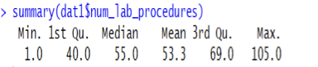

*Figure 4: Summary Statistics of num_lab_procedures variable*

After detecting the outliers, they were not removed but smoothed. The smoothing of outliers was performed on time_in_hospital, num_lab_procedures, num_procedures, num_medications, num_inpatients, num_outpatients, num_emergency and num_diagnosis variables. The process of smoothing outliers was implemented by converting the continuous variables to categorical variables. The conversion of variables was applied to continuous variable by grouping all the values below 1st quartile value in one category, grouping all the values between 1st and 3rd quartile values in another group and grouping all the values above 3rd quartile in separate category. As seen in Figure 5, the continuous variable is converted into a categorical variable by creating categories. In this way, the outliers were smoothed.

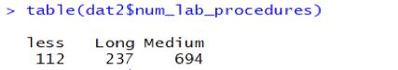

*Figure 5: Frequency of categories of num_lab_procedures variable*

**Dimension reduction/aggregation**

**Reducing Categories**

The process of category reduction was performed on variables having huge categories as this process would reduce the dataset complexity. The variable diag_1 had 848 distinct categories in the form of ICD9 codes. Therefore, it was very crucial to perform category reduction on this variable. At first, this reduced 848 categories to 18 by grouping the categories according to the diseases indexing provided on the ICD9 website. Further reduced these 18 to 9 by combining categories to “others” category. This grouping of categories was performed on the categories having observations less than 3% of total observations. Figure 6 depicts the number of observations in each category in diag_1 after performing the category reduction process. Similar cleaning was performed on variables diag_2 and diag_3.

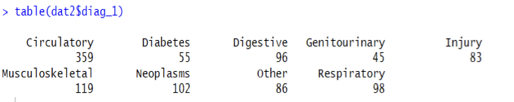

*Figure 6: Frequency of categories of diag_1 variable*

**Combining Categories**

The model building would be performed on the binominal output variable but the output variable that the readmitted had 3 categories. Therefore, the first 2 categories of the output variable were combined. Likewise, the age variable had 10 categories as seen in the Figure 7. In the research performed prior to the data preprocessing process, it was observed that the age of diabetes patients is above 60 years.

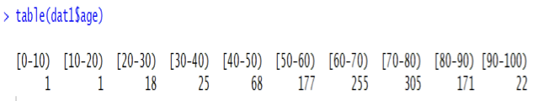

*Figure 7: Frequency of categories of age variable*

Hence, the 10 categories of the age variable were combined to 3 categories as shown in Figure 8. The category Above60 had the majority of observations; therefore, the basis for combining the categories was reasonably right. Further, the category combination process was performed on other categorical variables having numerous categories such as race, admission type, discharge disposition, admission source and payer_code. The categories of these variables were collapsed to the category “others”, and this method was applied to categories that had observations less than 3% of the total observation.

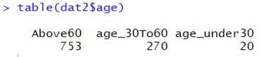

*Figure 8: Combined categories of age variable*

**Data Mining Algorithms**

The objective of the project is to classify diabetic patient readmission to the hospital. There are almost 50 predictors and more than 100,000 records were selected to classify the readmission of the patient in any of the hospital.

Classification is the process of classifying a process or record based on some shared characteristics. The goal of classification is to accurately predict the target class for each case in data. The output variable is categorical in a classification problem and hence it will be either one value or another. There won’t be a continuous range of values, so the graph of the output variable vs any of the predictor will always be a graph with those categorical values. There are two types of classification problems: binary classification and multiclass classification. In Binary classification, each record belongs to either one class or another. There won’t be any value apart from 0 or 1.

Classification is used to predict a dependent variable with more than two values. In this case the model is called multinomial classification problem or multiclass classification.

There are many classification algorithms to classify the dependent variable into one of the classes: Logistic regression, CART, Random Forest, K-Mean etc.

**Logistic Regression**

Logistic regression is a method for fitting a regression curve where output variable is categorical. This model is used to predict y on given predictors x. The predictors can be categorical, continuous or a mix of both. Logistic method is a statistical method of analyzing a dataset in which there are more than one independent variable determines outcome. The outcome is measured with a dichotomous variable, and here, there are only two possible values – 1 and 0 like binary.

*logit transformation*

Logistic regression returns the probability that the binary dependent variable may be predicted from the independent variables.

Our analysis includes 50 independent variables and one binary outcome variable called “readmitted”.

In this project, logistic regression is performed to find the readmission of a particular diabetic patient. If the patient is readmitted to a hospital then the value equal to 1 will be assigned to the

Data Mining Report on Diabetic Patient Readmission

The goal of logistic regression is to find the best fitting (yet biologically reasonable) model to describe the relationship between the dichotomous characteristics of interest (dependent variable = response or outcome variable) and a set of independent (predictor or explanatory) variables. Logistic regression generates the coefficients (and its standard errors and significance levels) of a formula to predict a of the probability of presence of the characteristic of interest. Rather than choosing parameters that minimize the sum of squared errors (like in ordinary regression), estimation in logistic regression chooses parameters that maximize the likelihood of observing the sample values readmitted variable. There are 30 independent variables that are used to determine the class of the upcoming patient as readmitted or not readmitted. Since our dataset includes more than 100,000 records so, we have used R-programming language for our model building.

**Package used:** glm package, we have used generalized linear model to perform logistic regression on diabetic dataset.

**Function used**: glm(), glm() functions are functions in glm package and used to perform logistic regression. It takes parameter as:

Formula: "formula", Basically, it is the formula of the logistic regression that we want to get after running our dataset with glm function. It represents the linear relationship between independent variables and dependent variable.

Data: a dataframe, which contains the variable of the model. If data is not found then glm() function takes the variable from the environment in which it is found. This contains the dataset on which we want to build our model. Training dataset is used to build the model and validation dataset is used to evaluate the performance of the model and test dataset is used to determine the accuracy of the model. an object of class called a symbolic description of the model to be fitted. The details of model specification are given under ‘Details’.

Family: a description of the error distribution and link function to be used in the model. We have run the logistic regression 3 times:

1. Min model: By only considering the intercept and the outcome variable i.e. readmission. This model is called minimum model or reference model.

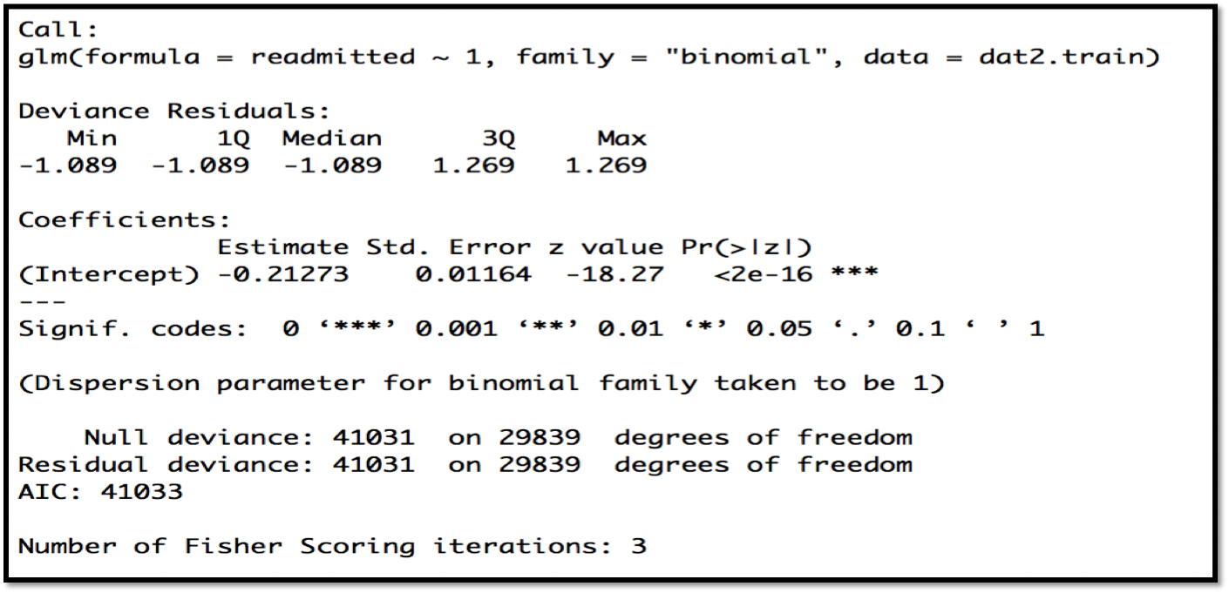

2. Max model: this model is built over full dataset also called as full model. There is no variable selection method used to build this model. This model has a high error rate and low accuracy.

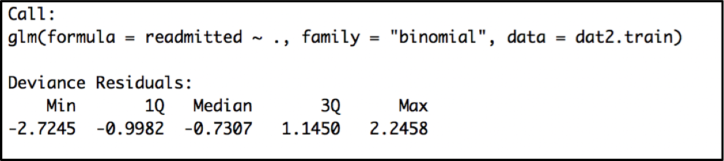

**Equation for the full model**:  
**readmitted ~ encounter_id + patient_nbr + race + gender + age + admission_type_id + discharge_disposition_id + admission_source_id + time_in_hospital + medical_specialty + num_lab_procedures + num_procedures + num_medications + number_outpatient + number_emergency + number_inpatient + diag_1 + diag_2 + diag_3 + number_diagnoses + max_glu_serum + A1Cresult + glimepiride + glipizide + glyburide + pioglitazone + insulin + change + diabetesMed**

In the output above, the first thing we see is the call, this is R reminding us what the model we ran was, what options we specified, etc.

Next, we see the deviance residuals, which are a measure of model fit. This part of the output shows the distribution of the deviance residuals for individual cases used in the model.

The next part of the output shows the coefficients, their standard errors, the z-statistic (sometimes called a Wald z-statistic), and the associated p-values.

Coefficient of the full model – The logistic regression coefficients give the change in the log odds of the outcome for a one unit increase in the predictor variable at a time by keeping others constant.

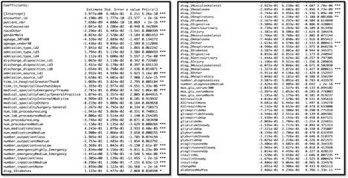

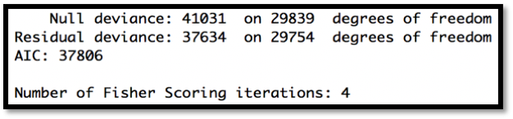

**Odds Ratio:**

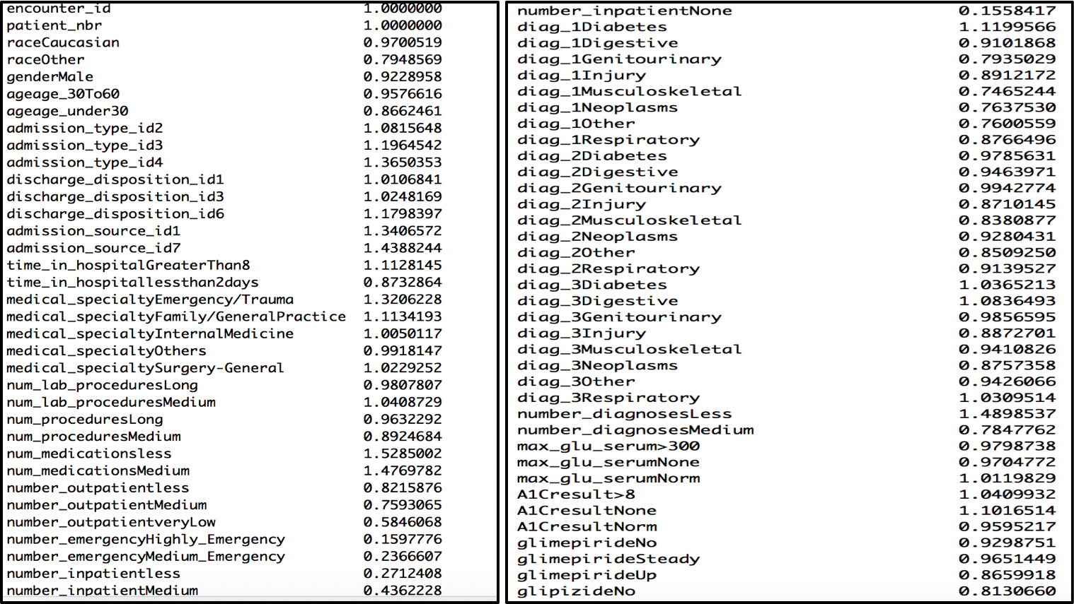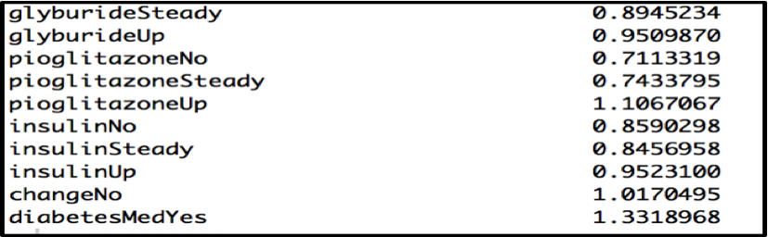

3. Best model: this model is built using reduced dataset. It has considered forward variable selection method to reduce the number of variables selected. This model has only considered the significant variables, those add significant information to the model.

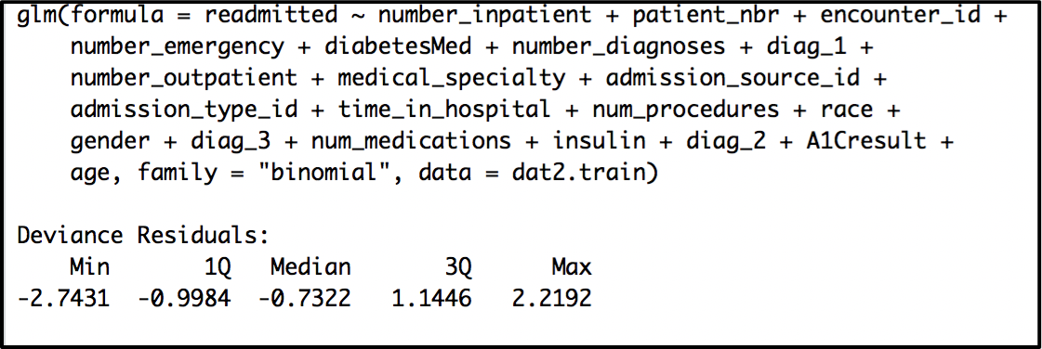

**Logistic Equation of best model:**

**readmitted ~ number_inpatient + patient_nbr + encounter_id + number_emergency + diabetesMed + number_diagnoses + diag_1 + number_outpatient + medical_specialty + admission_source_id + admission_type_id + time_in_hospital + num_procedures + race + gender + diag_3 + num_medications + insulin + diag_2 + A1Cresult + age**

Coefficient of independent variables in model: The coefficients give the change in the log odds of the outcome for a one unit increase in the predictor variable at a time by keeping others constant

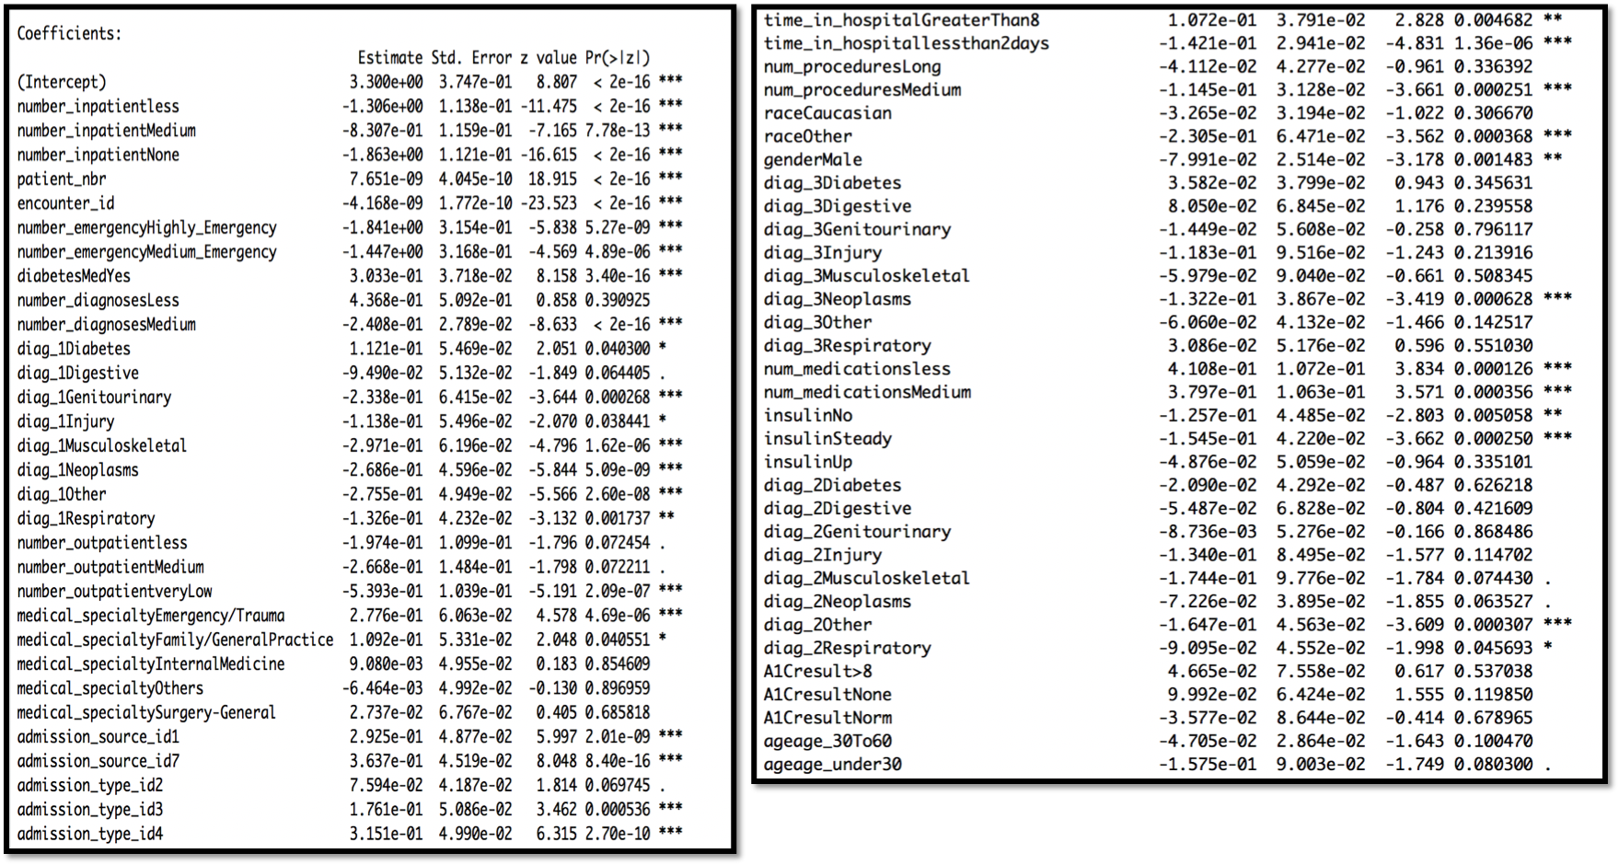

**Odds ratio of the Best model: Odd ratio**

Significant variable:  
The variables are arranged in decreasing order of significance level of each independent variable.

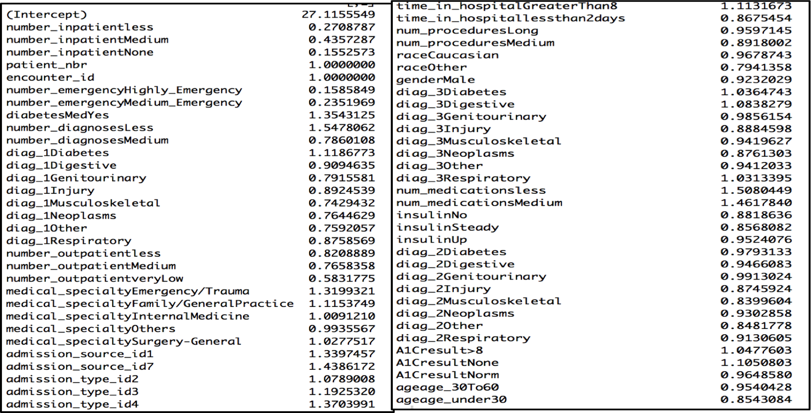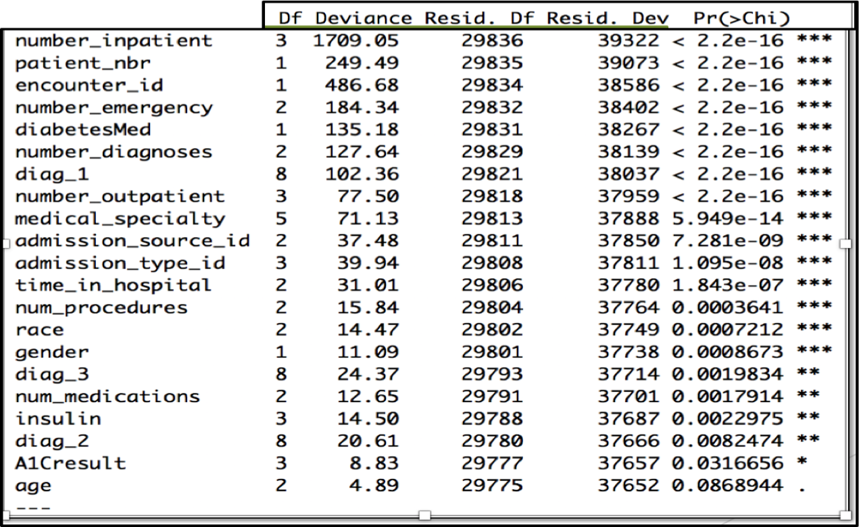

As you can see from the above table, number_inpatient, Patient_nbr,encounter_id, number_emergency etc are highly significant and age is the least significant variable in the model. It means a change in age is not very important in the readmission of the patient.

**CART**

Classification and Regression Tree is one of the most commonly used decision tree algorithms. CART algorithm is used for both classification and regression problems.

A decision tree is a recursive partitioning decision approach and CART splits each of the input nodes into two child nodes, so a CART decision tree is binary decision tree. At each level of the decision tree the algorithm identifies a condition that indicates which variable and level should be used for splitting input nodes into two decision child nodes. Splitting data at each node is done by using one variable only. It decides the best cutoff value of each variable at the decision node by two measures, Gini Index and entropy value. Higher Gini index values corresponds to better split point. CART is basically a successive if-else statement of a programming language.

The output variable of the CART algorithm can be both continuous and categorical. If the target variable is categorical, the tree is used to identify the class of the target variable. If the target variable is continuous, then the tree is used to predict its value.

CART algorithm has certain unique features that other classification algorithms don’t, like overfitting. CART algorithm never overfits the data. It automatically deals with the problem of overfitting.

CART algorithm found favor among researcher for its applications in the field of medicine, agriculture, management, forestry, natural resource management etc., as an alternative to the conventional approaches such as discriminant function method, Multiple regression method, Logistic regression etc.

The project includes the full tree and best prune tree for the classification of readmission of a diabetic patient. We have implemented this algorithm in R programming language.

Package name: rpart is used to build the tree in R.

**Full Classification Tree:**

Function:  
fit = rpart(readmitted ~ ., method="class", data=dat2, minsplit=10)  
Where, rpart: function to perform CART algorithm in R under package name rpart Method: a parameter in rpart to specify this method is for classification  
Data: dataframe on which the tree has to grow.  
Minsplit: minimum number of split allowed at each level.

**Summary of Full classification tree:**

This shows the variable importance of the model, in which number_inpatient is 96% and number_emergency is 6%. This also states that the classification of diabetic readmission is very much dependent on the number_inpatient.

Here, node 1 is the root node and it holds the full dataframe, whereas node 2 is the not admission node, which holds 32940 observation and node 3 is the success node which holds 16794 records and states that 16794 records have number_inpatient value greater than 0.5 and they belong to readmission class.

Data Mining Report on Diabetic Patient Readmission

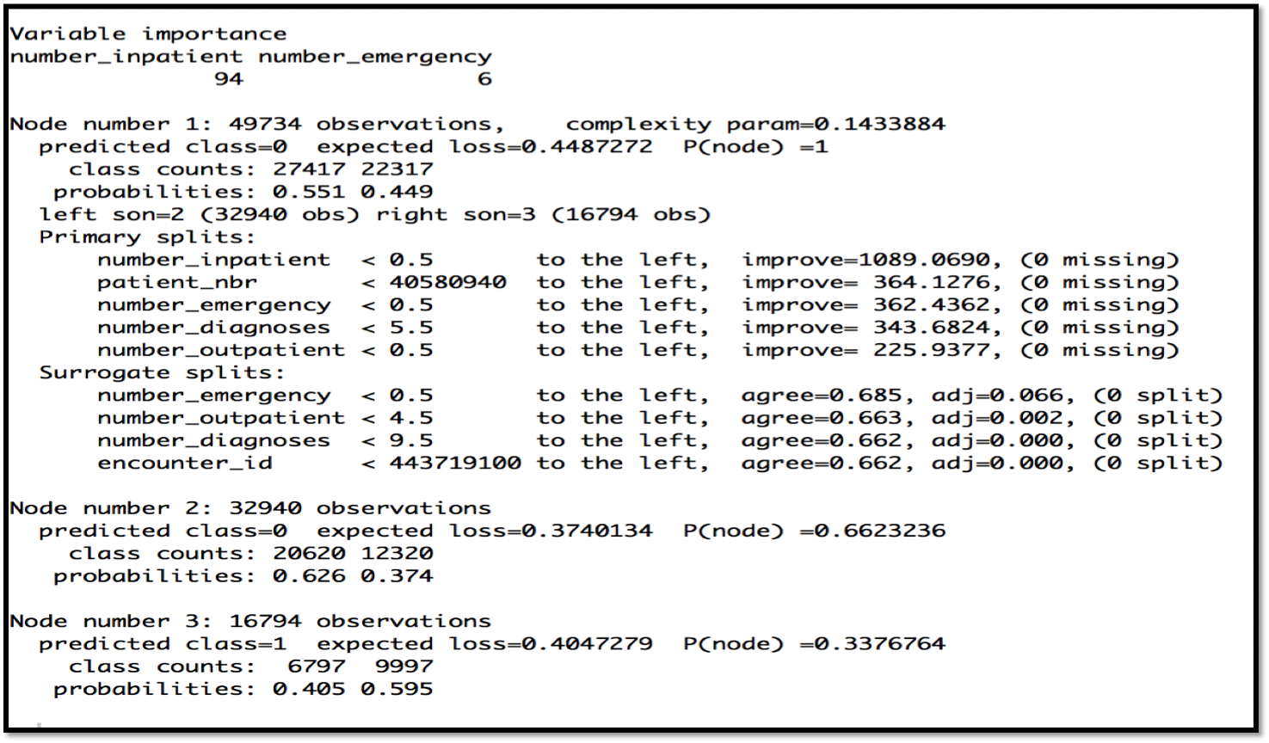

**Classification Tree:**

**Measuring Complexity of the Full Tree**

Cp table: A matrix of information on the optimal prunings based on a complexity parameter for each node.

Conclusion: as we can see from the tree, this tree is not complex and has only one split, but in real scenario there are many factors that significantly contribute to the admission or readmission of a diabetic patient.

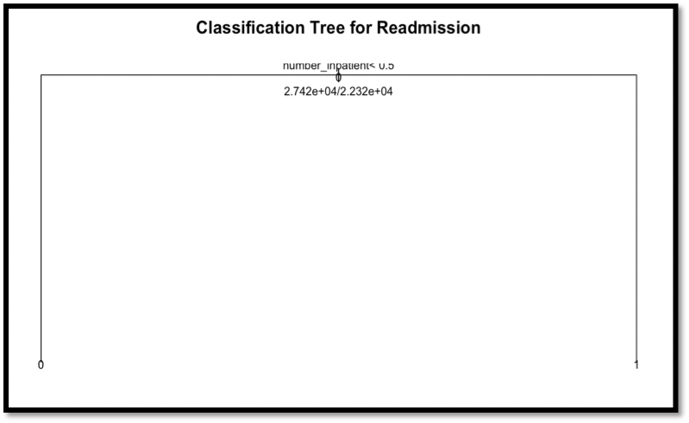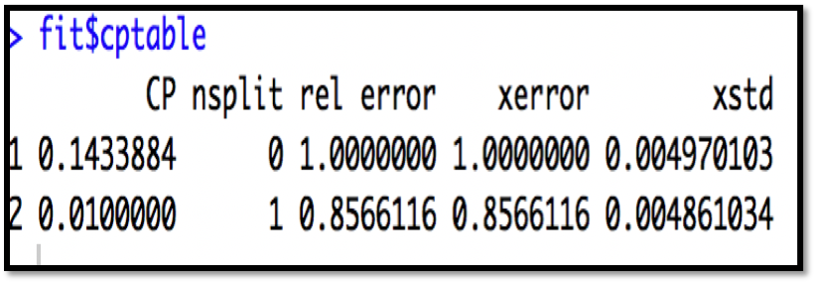

**Best Prune Tree:**

Function used:

prune(fit, cp = fit$cptable[which.min(fit$cptable[,"xerror"]),"CP"])

Where Cp: Complexity parameter to which the rpart will be trimmed

cptable: An object of rpart which is a matrix of information on the optimal prunings based on a complexity parameter.

**Summary of Prune Tree:**

This shows the variable importance of the model, in which number_inpatient is 96% and number_emergency is 6%. This also states that the classification of diabetic readmission is very much dependent on the number_inpatient.

Here, node 1 is the root node and it holds the full dataframe, whereas node 2 is the not admission node, which holds 32940 observation and node 3 is the success node which holds 16794 records and states that 16794 records have number_inpatient value greater than 0.5 and they belong to readmission class.

Data Mining Report on Diabetic Patient Readmission

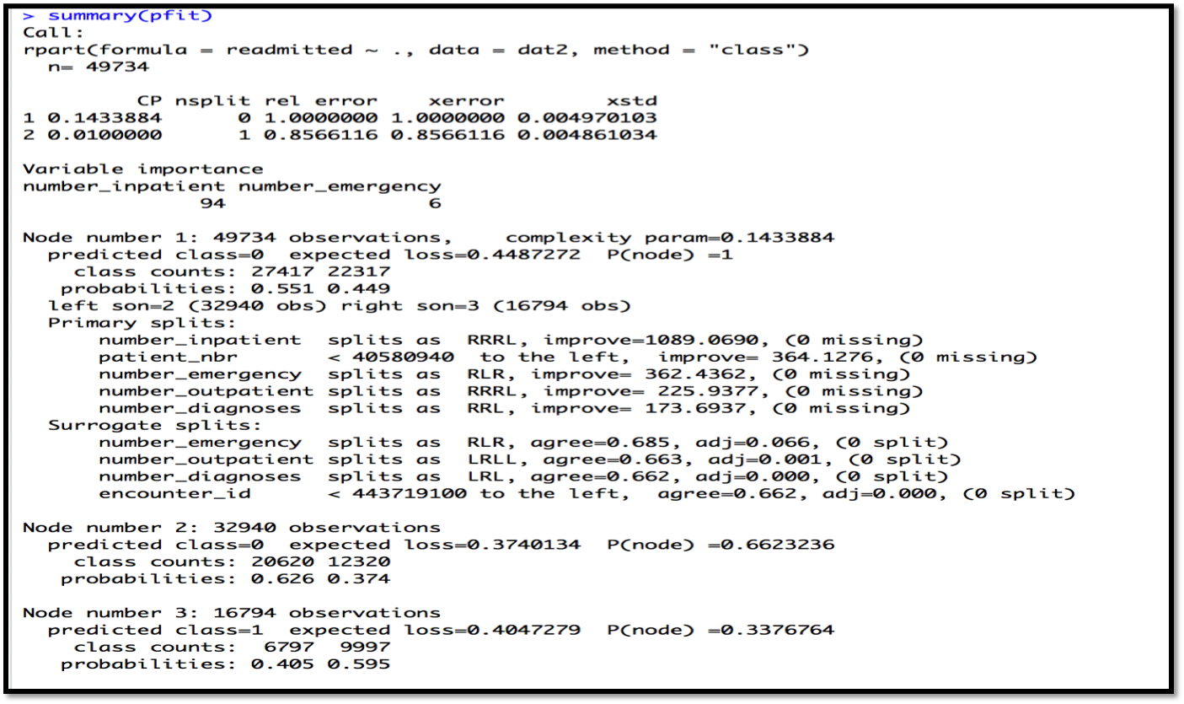

**Best Prune Tree:**

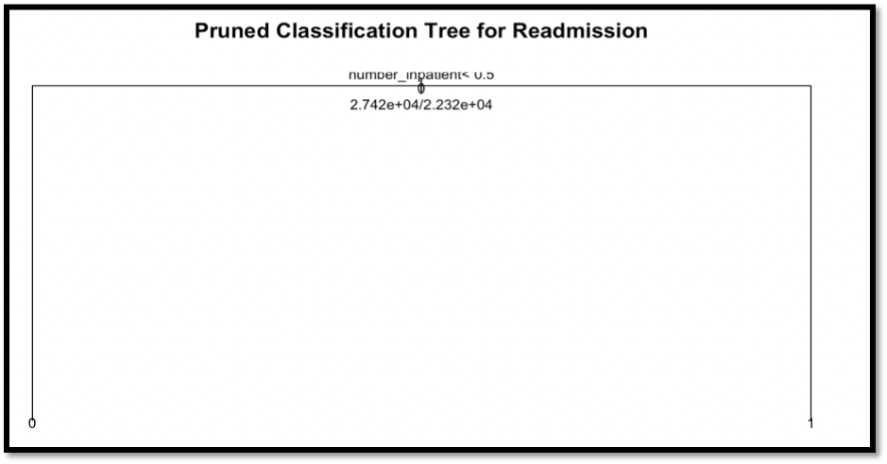

**Model Interpretation**

**Logistic Regression  
Likelihood Ratio Test (LR Test) and Analysis of Variance (ANOVA) for Goodness of Fit:**

Data Mining Report on Diabetic Patient Readmission

A logistic regression model is considered a better fit to the data if it demonstrates an improvement over a model with fewer predictors. This can be achieved using Likelihood Ratio Test (LR) and Analysis of Variance (ANOVA), these test compares the probability of the data under the full model against the likelihood of the data under a model with fewer predictors. Removing predictor variables from a model will almost always make the model fit less well (i.e. a model will have a lower log likelihood), but it is necessary to test whether the observed difference in model fit is statistically significant. Given that H0 holds that the reduced model is true, a p-value for the overall model fit  
A statistic that is less than 0.05 would compel us to reject the null hypothesis. It would provide evidence against the reduced model in favor of the current model.

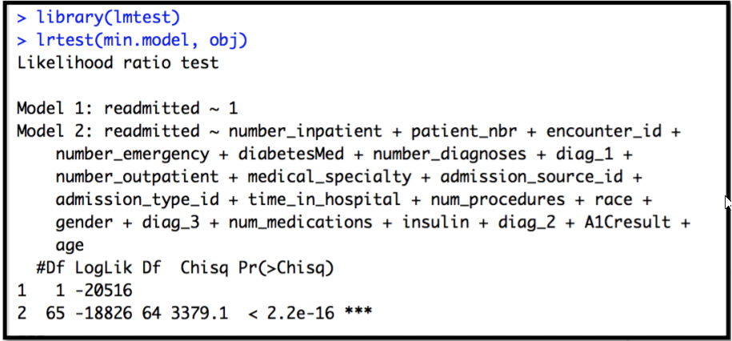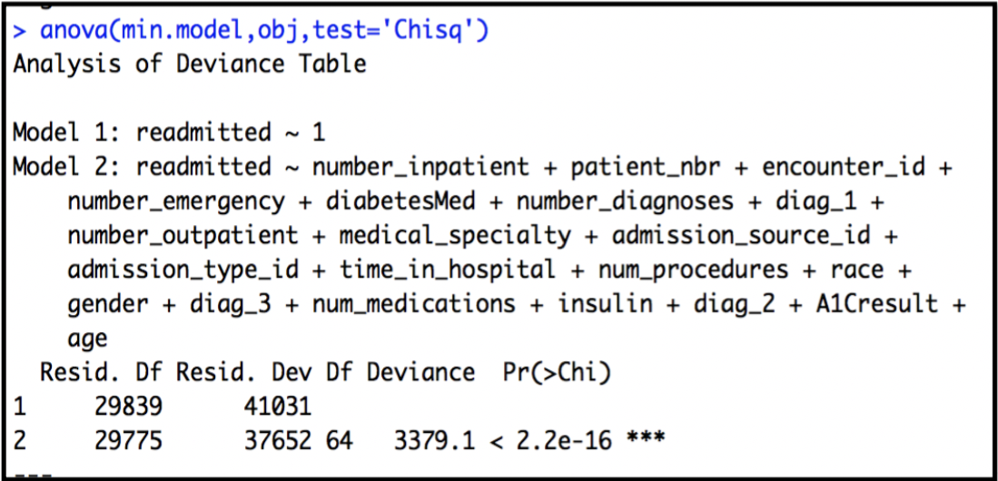

**Accuracy and Confusion/Classification Matrix**

Accuracy of the model through Logistic Regression is 64.39% and from the result of the confusion or classification matrix is below:  
**true positives (TP):** These are cases in which we predicted yes, and they were readmitted. (2150)

**true negatives (TN):** We predicted no, and they were not readmitted. (10020)  
**false positives (FP):** We predicted yes, but they were not readmitted. (Also known as a "Type I error.")(896)  
**false negatives (FN):** We predicted no, but they were readmitted. (Also known as a "Type II error.")(6828)

**ROC Curve:**

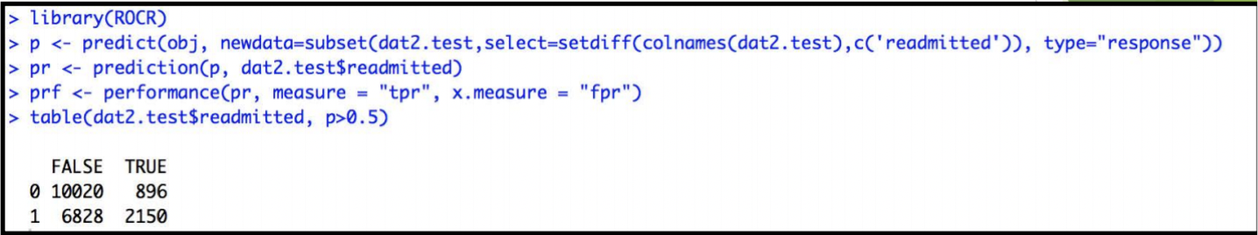

The receiving operating characteristic is a measure of classifier performance. Using the proportion of positive data points that are correctly considered as positive and the proportion of negative data points that are mistakenly considered as positive, we generate a graphic that shows the tradeoff between the rate at which you can correctly predict something with the rate of incorrectly predicting something.  
Ultimately, we’re concerned about the area under the ROC curve, or AUROC. That metric ranges from 0.50 to 1.00, and values above 0.80 indicate that the model does a good job in discriminating between the two categories which comprise our target variable. Bear in mind that ROC curves can examine both target-x-predictor pairings and target-x-model performance.

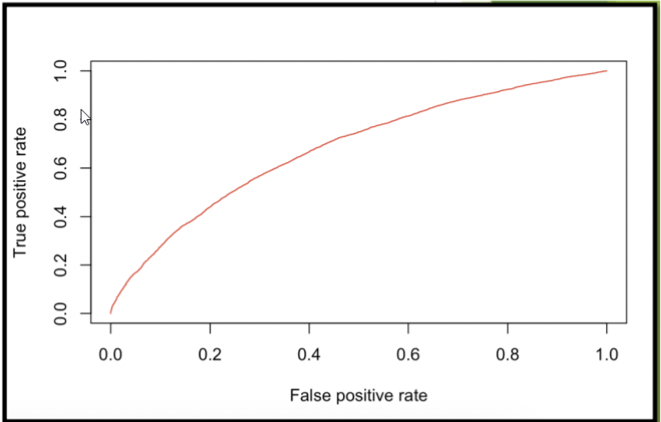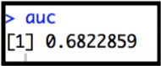

**Classification and Regression Tree (CART) Measuring the Fitness of Full Tree:**

The error at root node is 0.44873 and the variable used in Full tree construction are [1] number_inpatient.

Data Mining Report on Diabetic Patient Readmission

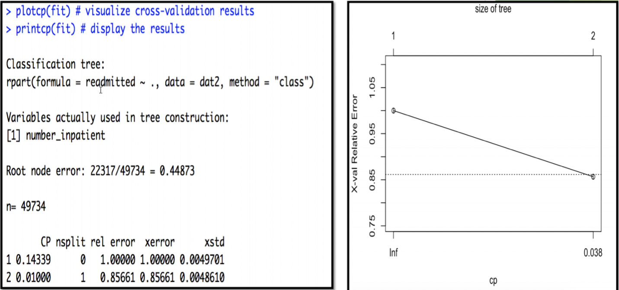

**Measuring Fitness of Prune Tree:**

The error at root node is 0.44873 and the variable used in Prune tree construction are [1] number_inpatient.

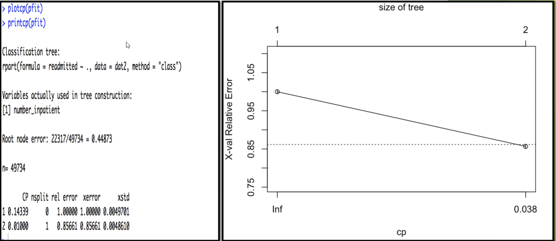

**Conclusion**

The goal of the project was to identify the factors that affect the readmission of diabetic patients into hospitals. The raw dataset consisted of patient-data spanning 10 years between 1999 and 2008 across 130 hospitals. It had 11 continuous and 39 categorical variables where, many records lacked values for important variables, had variables that weren’t of interest for our goal and also had outliers.

Data cleaning was performed on this dataset where variables were reduced from 50 to 30, categories within these variables were highly reduced using the ICD9 codes, variables like “weight” that had 93% missing values were omitted, and variables with outliers were smoothed out instead of being removed entirely.

The classification models applied to the dataset are CART and Logistic regression.

In the Logistic Regression model, the full, minimum and best models were run. Here the Best model with forward variable selection yielded the optimum number of variables, and has the best accuracy rate (64.39%) coupled with a low error rate. The next model run was CART, where the Full tree and the Best-prune tree were formulated, both of which yielded similar classifications. Also, the trees weren’t complex enough, and the relative error was high, and hence the model had to be discarded.

Finally, analysis on the dataset revealed that Caucasian women over the age of 60 are more susceptible to being readmitted. Also, we discovered the duration of being admitted and medication administered play an important role, as patients who stayed between 4 and 8 days and received diabetes medication are more likely to be readmitted.